HOW TO ACCESS CLASS ZOOM LINKS IN YOUR OASIS ACCOUNT
(Class Zoom links are also sent by email on the day before each class is scheduled.)
Go to your Oasis website and click on My Account at the right of the blue menu bar.

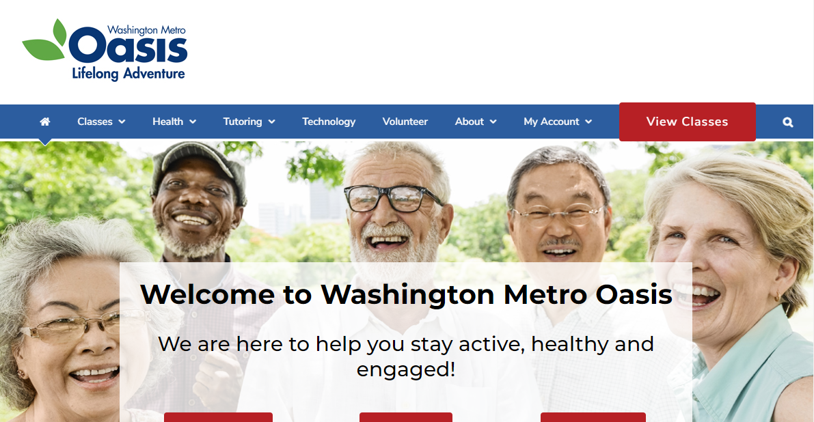

Enter your User Name and Password
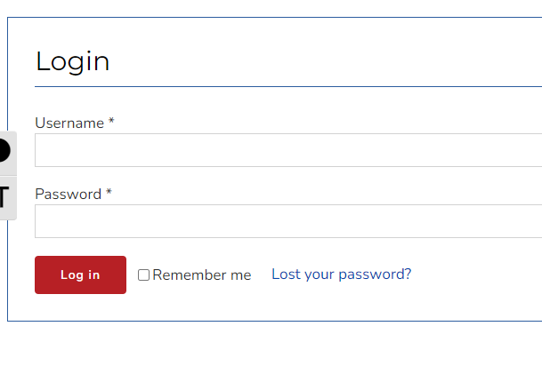
Then click Log in.

You will see your Oasis Dashboard.

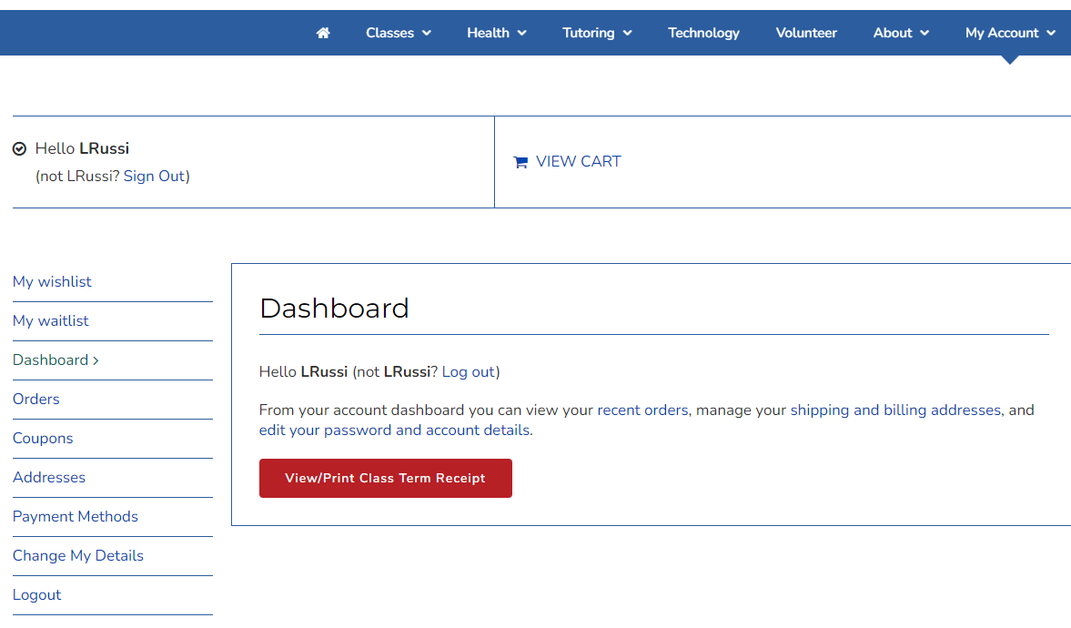

Click on Orders in the left menu.

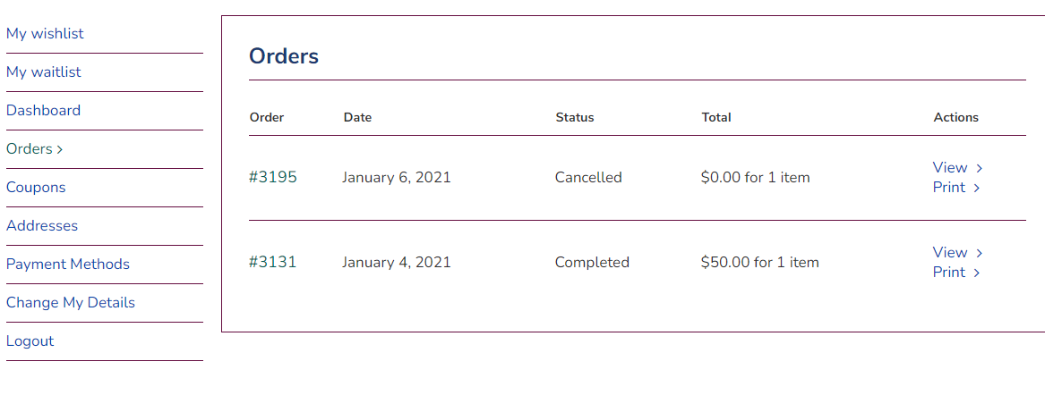
You will see a list of your current orders.
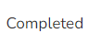

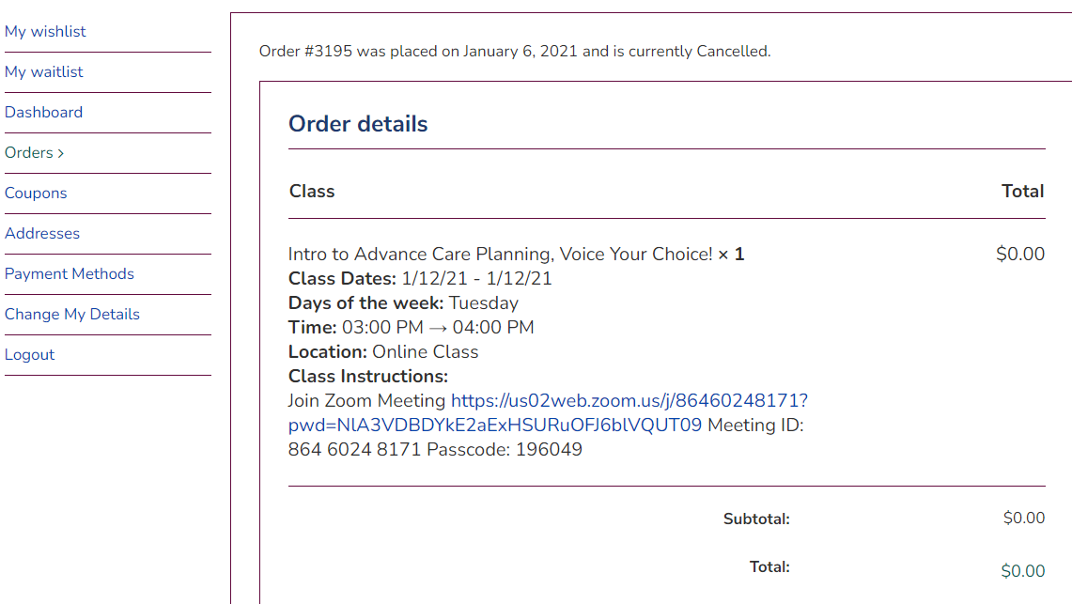
Click on the order number to view the details for that order including class details and Zoom links.

